**Home work 1 section1**

1. The angle between the vectors (1, 0, −1, 3) and (1,√3, 3, −3) in R4 is aπ, where a = _3/4_.

Sol:

Cose ɵ= v1.v2/|v1||v2|

v1.v2=element wise multiplication= -11

|v1|=sqrt(12+0+(-1)2 +32)=sqrt(11)

|v2|=sqrt(22)

Cose ɵ=-sqrt(2)/2

ɵ=135 ɵ=3/4 π

1. Which of the angles (if any) of triangle ABC, with A = (1, −2, 0), B = (2, 1,−2), and C = (6, −1, −3), is a right angle?

Answer: the angle at vertex _AB_.

Cose ɵ= v1.v2/|v1||v2|

Cose 90=0

So : v1.v2 must equal 0

A.B=2-2+0=0

1. Practice with numbers (if there is no answer, say so)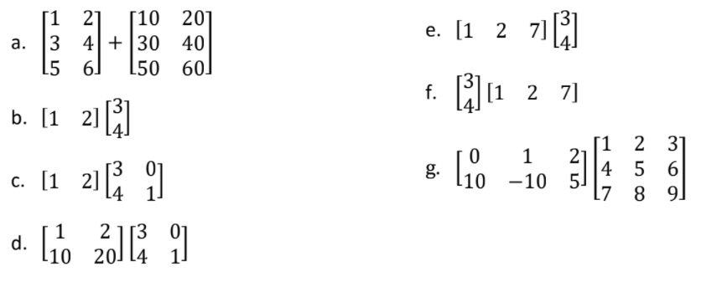
2. $\left[\begin{matrix}11 & 22 \\ 33 & 44 \\ 55 & 66\end{matrix}\right]$ b. 1*3+2*4=11 c. $[\begin{matrix}11 & 2\end{matrix}]$

d. $\left[\begin{matrix}11 & 2 \\ 110 & 20\end{matrix}\right]$ e. no must col = rows of 2nd matrix

f. $\left[\begin{matrix}3 & 6 & 21 \\ 4 & 8 & 28\end{matrix}\right]$ g. $\left[\begin{matrix}18 & 21 & 24 \\ 5 & 10 & 15\end{matrix}\right]$

4-If one side of the triangle increases by 11 cm and the other side decreases by the same value, we get an equilateral triangle. When the first side is multiplied by four, it is 10 cm longer than three times the third side. Find the lengths of the triangle's sides. Write this in a matrix-vector form

Sol:

Length of triangles=a, b ,c

a=b+11 🡪1 a=c-11🡪2 4b=10+3a🡪3

from 1 : b=a-11

4(a-11)=10+3a

a=54

b=54-11=43

c=a+11=65

Matrix form:

$\left[\begin{matrix}1 & -1 & 0 \\ 1 & 0 & -1 \\ -3 & 4 & 0\end{matrix}\right]$ $\left[\begin{matrix}a \\ b \\ c\end{matrix}\right]$ = $\left[\begin{matrix}11 \\ -11 \\ 10\end{matrix}\right]$

5-Two containers contain a water of different temperatures. If we mix 240 g of water from the first container with 260 g of water from the second container, the resulting water temperature will be 52°C. If we mix 180 g of water from the first container with 120 g of water from the second container, the resulting water temperature will be 46°C. What is the temperature of water in the containers?. Write this in a matrix-vector form.

Sol :

240 T1+260 T2=(240+260) *52

240 T1+260 T2=26000 🡪 1

180 T1+120 T2=13800 🡪 2

From 1 and 2 :

100 T2=7600

T2=76

T1=26

Matrix form:

$\left[\begin{matrix}240 & 260 \\ 180 & 120\end{matrix}\right]$ $\left[\begin{matrix}T1 \\ T2\end{matrix}\right]$ = $\left[\begin{matrix}26000 \\ 13800\end{matrix}\right]$

6- If one dimension of the cuboid increases by 1 cm, the surface area of the cuboid increases by 54 cm2. If the second dimension of the cuboid increases by 2 cm, the surface area of the cuboid increases by 96 cm2. If the third dimension of the cuboid increases by 3 cm, its surface area increases by 126 cm2. Find the dimensions of the cuboid. Write this in a matrix-vector form

Sol:

2lw+2lh+2wh=sa🡪1

2w(l+1)+2h(l+1)+2wh=sa+54🡪2

2l(w+2)+2hl+2h(w+2)=sa+96🡪3

2lw+2l(h+3)+2w(h+3)=sa+126🡪4

From 2 -1 :

2w+2h=54

W+h=27 🡪6

From 3-1 :

4l+4h=96

L+h=24🡪7

From 4-1 :

6l+6w=126

L+w=21🡪8

From 6 and 7 and 8 :

W= 12 l=9 h=15

Matrix Form:

$$\left[\begin{matrix}1 & 0 & 1 \\ 0 & 1 & 1 \\ 1 & 1 & 0\end{matrix}\right]\left[\begin{matrix}w \\ l \\ h\end{matrix}\right]=\left[\begin{matrix}27 \\ 24 \\ 21\end{matrix}\right]$$